|  |  |  |
| --- | --- | --- |
| American University of SharjahCollege of Engineering Dept of Computer Science & Engg  P. O. Box 26666  Sharjah, UAE |  | Instructors: Dr. Tamer [Shanableh](javascript:detailw('detail.asp?ID=@00010457')) **Lab Instructor:** Ms. Praveena Kolli  **Office** EB2-126  **Phone**: 971-6-5152352  **e-mail**: [pkolli@aus.edu](mailto:pkolli@aus.edu)  **Semester**: Spring 2023 |

**CMP354L -** [**Mobile Application Development**](https://banner.aus.edu/axp3b21h/owa/bwckschd.p_disp_detail_sched?term_in=201410&crn_in=11136)

**Lab1**

**Topics:**

* Building first android App
* Button onclick listener

**Exercise 1:**

Develop an app that test arithmetic skills. Your app randomly generates two numbers and an operator (+, -, *, /) in the respective widgets. The random numbers are in the range from 1 to 20.

Check Ans button checks the answer and if it’s correct the answer gets highlighted in green if not red.

Next button gets and displays new random numbers and an operator.

You may choose either table or constraint layout for the designing.

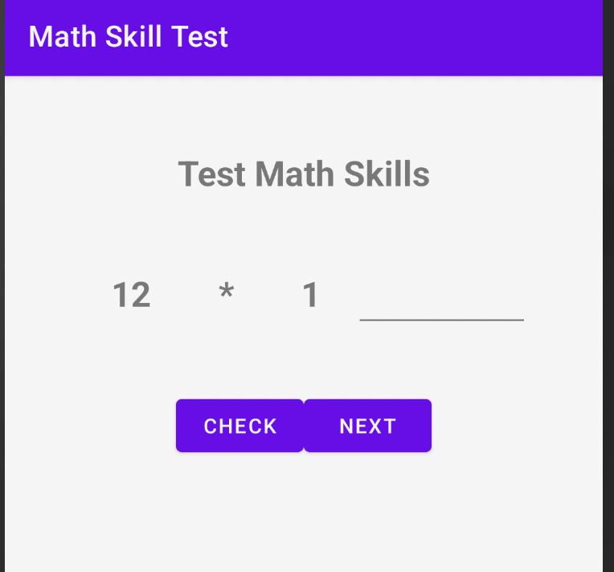

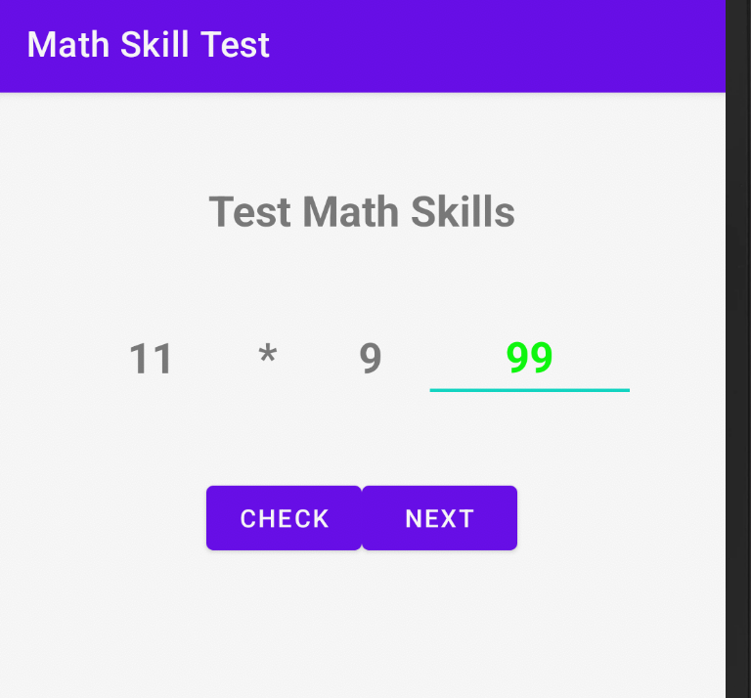

To change color of the EditText,

editTextAns.setTextColor(Color.*GREEN*);

editTextAns.setTextColor(Color.*RED*);

To get random values.

new Random().nextInt(11) -> generates random number in the range 0 to 10

**Note**: Submit Design xml, java code, screenshots of running app and **APK**. Do not upload a zip file. Submit lab document and apk as separate attachments.